Windows Demo Function demonstration

Revision history
number | Revised content description | revised by | revision date | Revised version number | approver
1 | first draft | 32725 | 2018/03/26 | 3.2
2 | Delete user mode correlation, support device video double speed playback | 357083 | 2023/03/22 | 3.11.6

Catalog
Windows Demo Function demonstration 1
1.Background 3
2.Summary 3
3. Function and Usage Introductions 3
1 Account login 3
2 Device List 5
3 Bind Device 5
4 Delete Device 6
5 Input video decryption key 6
6 Real-time Video & Intercom 7
7 PTZ Control 8
8 Video Playback and Cloud Video Downloads 8
9 Alarm Message 10
10 Device Setup 11

1.Background
In order to let developers quickly understand how to butt Lechange open platform Windows SDK, and have a glimpse of the SDK function, Lechange open platform team from the developer's point of view, developed Windows Demo applications based Windows SDK, for developers to reference.
Please refer to the Windows Demo project source code directory, the project mainly refers to Windows SDK, achieved some of the core functionality of video. Developers can draw on features in Demo (including code implementations) to their own developed applications

2.Summary
This document is a functional demonstration document for Windows Demo. If developers only want to understand the main functions of Demo implementation, can directly read the document. If you want to further experience the function of Demo, you can deploy the Demo project to your IDE, compile, debug and run

3. Function and Usage Introductions

1 Account login
The Lechange open platform provides an administrator mode docking for third party applications (IOS/Android/Windows applications), as described in detail https://open.imoulife.com/book/readme/account.html.

Admin mode
Run Demo, the homepage as shown below. Enter AppID and AppSecret, click to enter administrator mode.
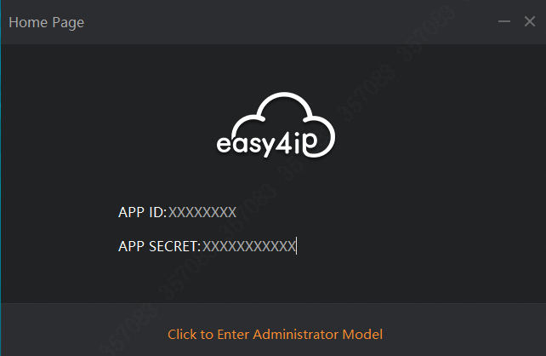

2 Device List
After you successfully login device, Demo will get device list under this account from Lechange open platform. If no device gotten, you can bind device, see Bind Device.
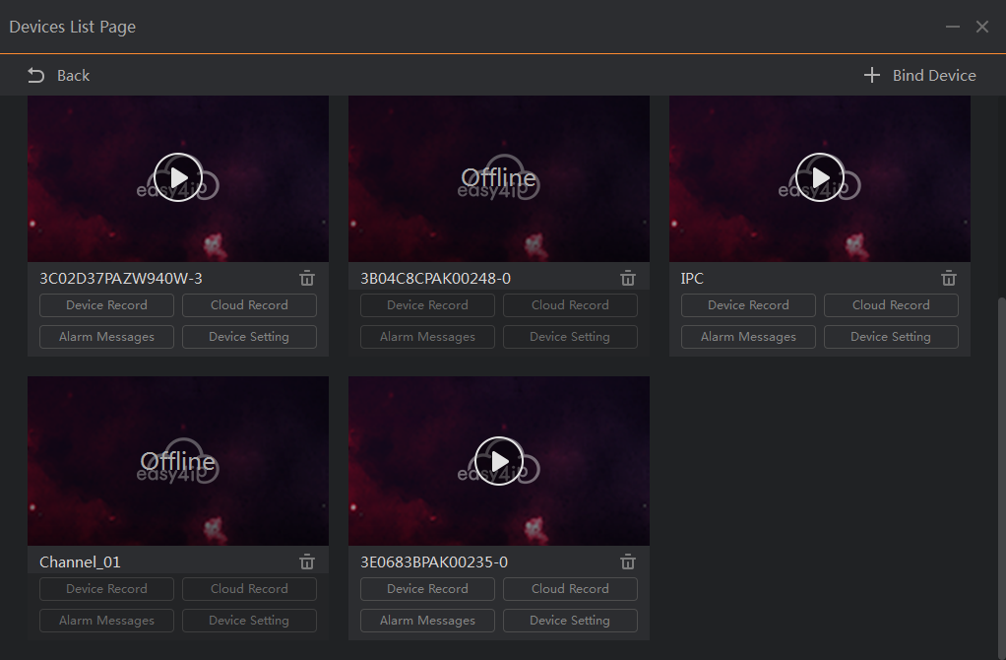

3 Bind Device
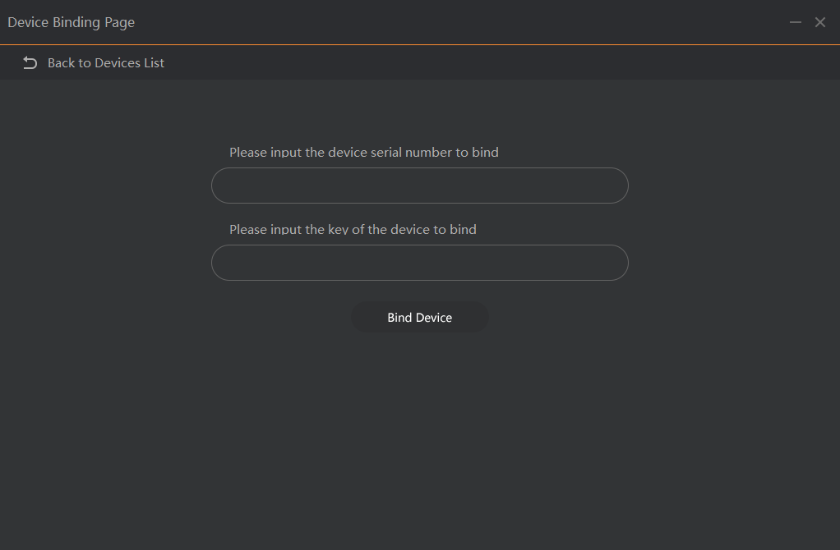
Device binding process is as follows:
The first step, make sure that the Demo and device are in the same LAN;
The second step, in bind device page, enter the device serial number and device password, click bind device button(for device required to be initialized, Demo will initialize device before binding, and then device needs a little time to connect Lechange open platform to bind again);
The third step, after successful binding, click return to the device list, refresh the device list page, you can see the newly bound device

4 Delete Device
In the device list page, click the delete button of a device view, and automatically refresh the device list page after the deletion is successful.
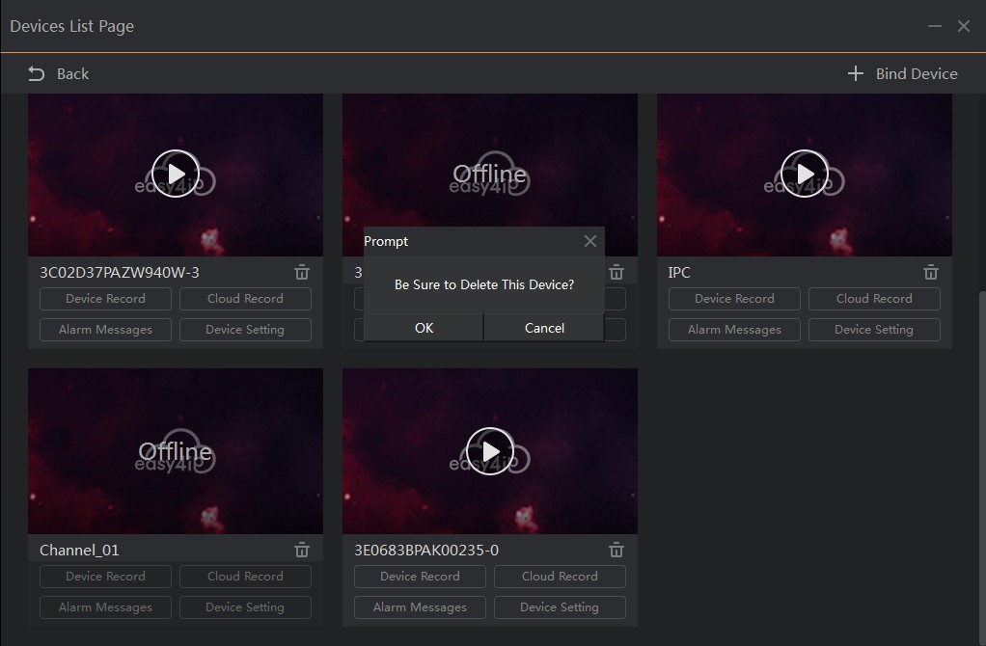

5 Input video decryption key
For devices that are online and have a video custom key set, you need to enter the video decryption key before you can operate the device (except for device deletion), as shown in the following figure:
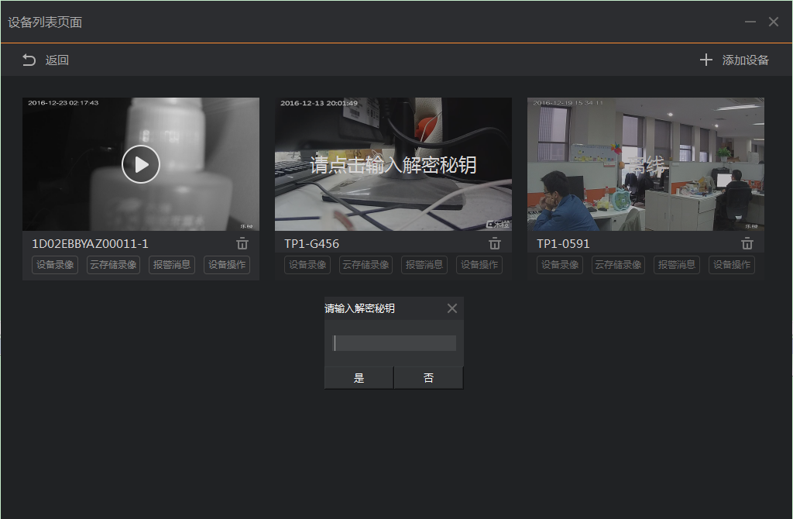

6 Real-time Video & Intercom
In the device list page, click the live play button of a device view, as going to live video page, see following figure:
The preview window below includes snapshot, record, HD / SD switch, on/off intercom, on/off audio, full screen/normal , and PTZ control, a total of 7 function buttons.
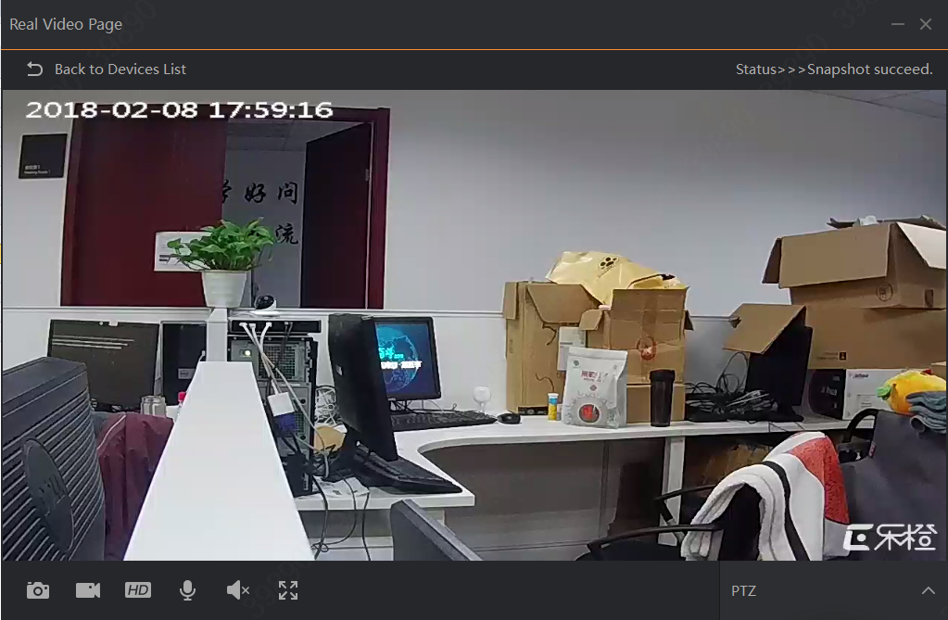

7 PTZ Control
In live preview page, click the PTZ Control button, which pops up the pan tilt control window, as shown in the following figure:

Click the button to rotate in all directions, PTZ. (Note: only for PTZ control function devices.)
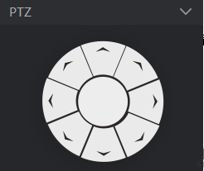

8 Video Playback and Cloud Video Downloads
In the device list page, click device record button of a certain device view, as going to device video list page, as shown below:
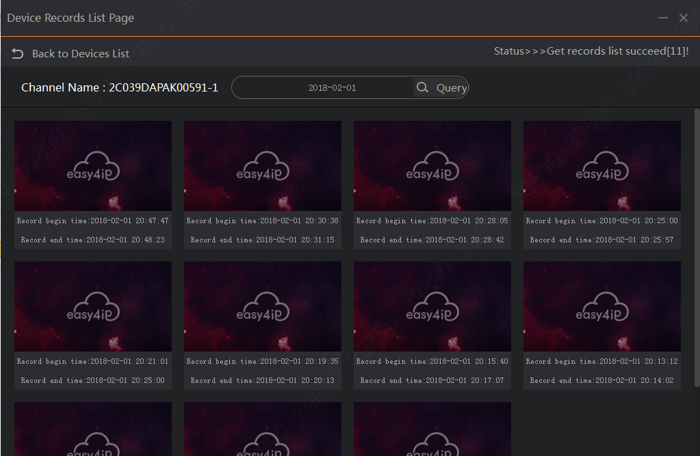

In the device list page click Cloud Storage Record button of a certain device view, as going to cloud video list page, as shown below:
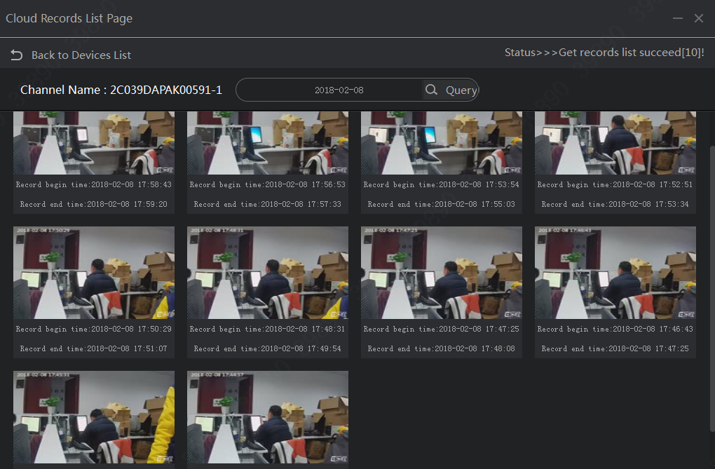

(Note: Demo by default only search the 10 most recent videos of today, can also choose the date of inquiry)

Click play button of a certain record view in the device record/cloud record list page, as going to device record/cloud record playback page, as shown below:
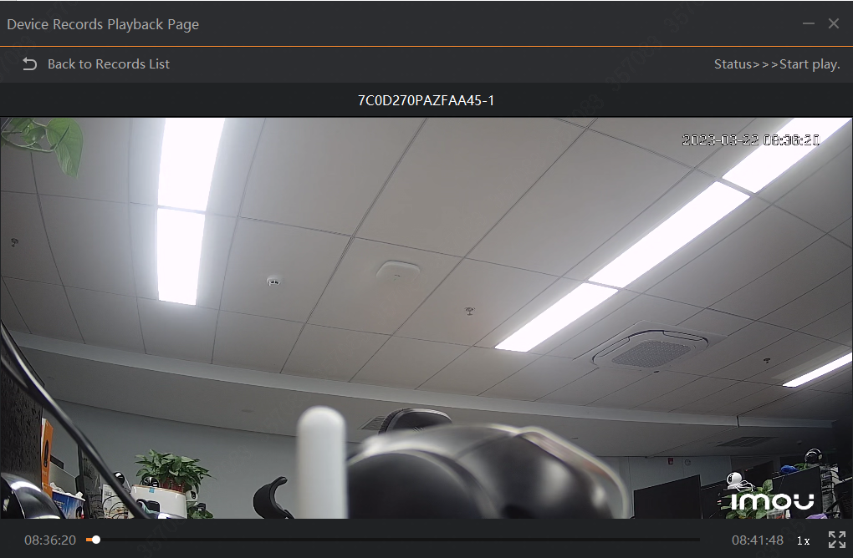

Click download button of a certain record view in cloud record list page to download the cloud video, as shown below:
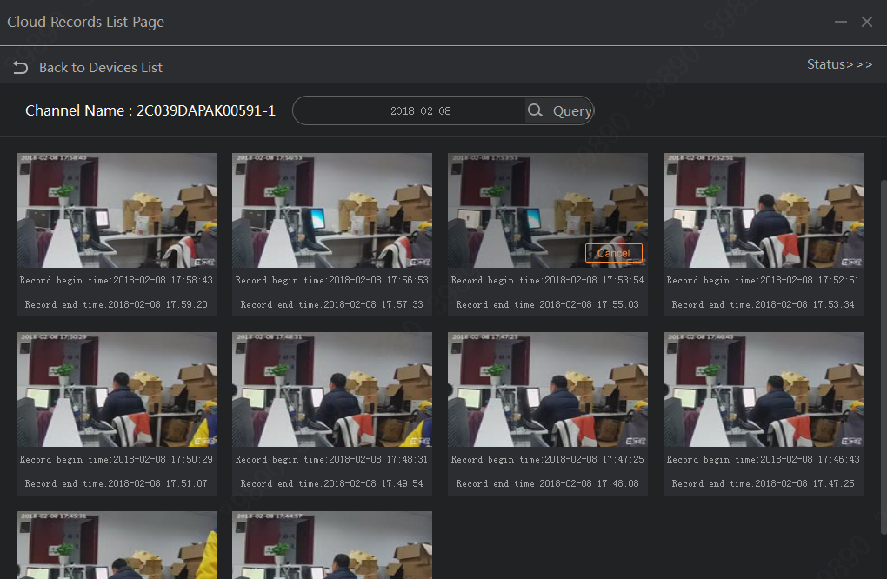

9 Alarm Message
Click alarm message button of a certain device view in the device list page, as going to alarm message list page, as shown in the following figure:
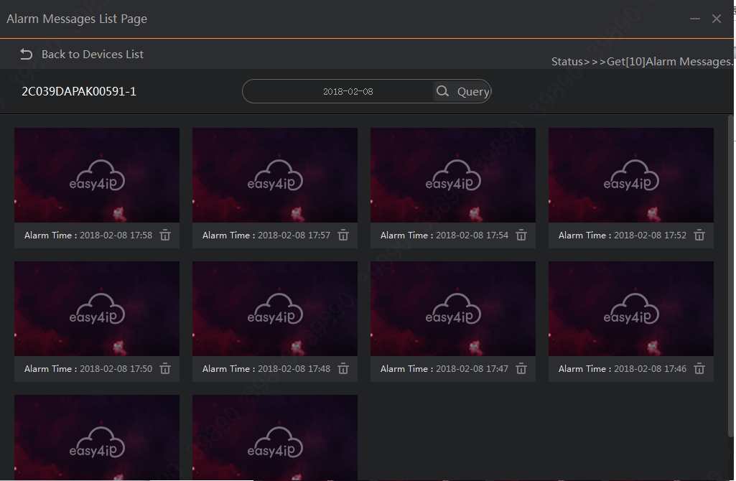

(Note: Demo by default only search the 10 most recent alarm messages of today, or you can select date.)

10 Device Setup
Click the device settings button of a certain device in the device list page, as going to device settings page, as shown in the following figure:
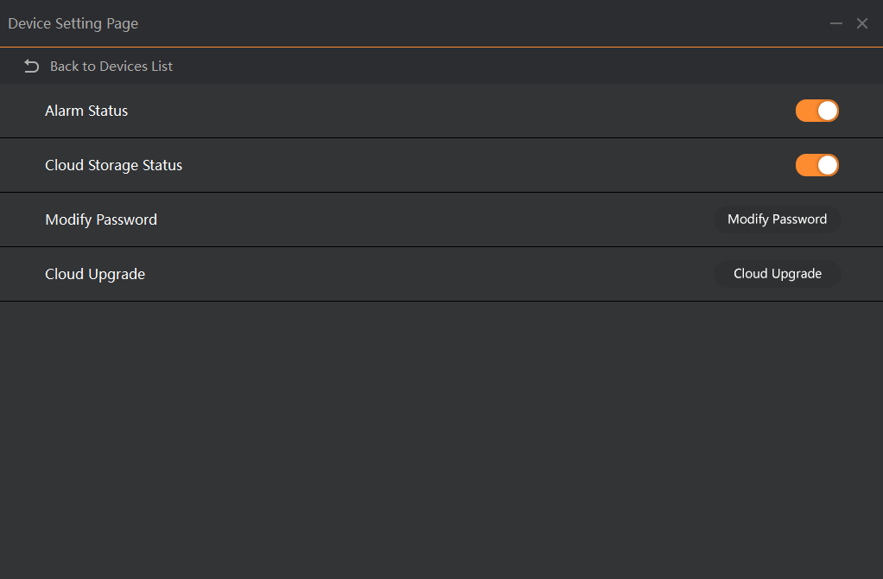
Note:
- Enable alarm status, so it alarms when change occurs in video.
- Enable cloud storage status, open device cloud record upload function.
- Change password, change device login password.
- Cloud upgrade, upgrade device firmware.

